

**Space Checker**

**Interim Report**

**DT228**

**BSc in Computer Science**

**Jianyu He**

**D17124591**

**Martin Mchugh**

School of Computer Science

Technological University, Dublin

**29/11/2019**

**Abstract**

**The goal of this project is to develop efficiency of driver, it able to helps driver find suitable car space using website.**

**Our project is to design an application use to check amount of car, car space and space status in the car park by cctv. The application is going to show car space available and a simple car space map on the website live that driver can check car space on the website, this application is help for driver to check how many car space available in car park and do not need waste time to check car space in the car park.we are going to create a database for our project. This database will store details of user, car park and space.**

**For this project, we do not want cost money to purchase a cctv and set into car space, so we would like to use video from car park to test this program.**

**Declaration**

I hereby declare that the work described in this dissertation is, except where otherwise stated, entirely my own work and has not been submitted as an exercise for a degree at this or any other university.

Signed:

_________________________

Student Name

Date

**Acknowledgements**

I wish to acknowledge my supervisor Martin Mchugh for him guidance and support from the proposal stages and interim report of the project and throughout. I also wish to thank Damain Gordon for him tireless work coordinating our final year project module.

Table of Contents

1. Introduction 7

1.1. Project Background 7

1.2. Project Description 7

1.3. Project Aims and Objectives 7

1.4. Project Scope 7

1.5. Thesis Roadmap 7

2. Literature Review 8

2.1. Introduction 8

2.2. Alternative Existing Solutions to Your Problem 8

2.3. Technologies you’ve researched 8

2.4. Other Research you’ve done 8

2.5. Existing Final Year Projects 8

2.6. Conclusions 8

3. Prototype Design 9

3.1 Introduction 9

3.2. Software Methodology 9

3.3. Overview of System 9

3.4. Front-End 9

3.5. Middle-Tier 9

3.6. Back-End 9

3.7. Conclusions 9

4. Prototype Development 10

4.1. Introduction 10

4.2. Prototype Development 10

4.3. Front-End 10

4.4. Middle-Tier 10

4.5. Back-End 10

4.6. Conclusions 10

5. Testing and Evaluation 11

5.1. Introduction 11

5.2. Plan for Testing 11

5.3. Plan for Evaluation 11

5.4. Conclusions 11

6. Issues and Future Work 12

6.1. Introduction 12

6.2. Issues and Risks 12

6.3. Plans and Future Work 12

6.3.1. GANTT Chart 12

Bibliography 13

# 1. Introduction

This chapter is about the introduction of project, it list project background, project description, project aim and objectives, project scope and Thesis Roadmap.

## Project Background

As the Population expansion and for the convenience of travel, more and more people buy cars[1]. As results some car park may very busy, that we design this application to help drive do not have to waste time to check does any space left[2]. Python is the best programming language use computer vision to process images.[3] [4]

References:

[1] Aindrila Biswas1, Angshu Mukherjee2 and Mousumi Roy, June 2014, “Leveraging Factors for Consumers’ Car Purchase Decisions- A Study inan Emerging Economy” <http://webcache.googleusercontent.com/search?q=cache:http://jmppnet.com/journals/jmpp/Vol_2_No_2_June_2014/8.pdf>

this scholar is describe why people like to use a car, that is to help to analyze why people have to buy a car.

[2] MariaBörjesson. JonasEliasson, January 2014, “Experiences from the Swedish Value of Time study” <https://doi.org/10.1016/j.tra.2013.10.022>

this scholar describe how sense of time is important for human development, that is helping me to help to analyse how our project will help people.

[3] Joseph Howse (2013) “OpenCV Computer Vision with Python” <https://books.google.ie/books?hl=zh-CN&lr=&id=OQm3gNQ7xGcC&oi=fnd&pg=PT8&dq=python+with+computer+vision&ots=42ppJZep_1&sig=NA0_MWfJP_kOKBO3qR91GyYtCbE&redir_esc=y#v=onepage&q=python%20with%20computer%20vision&f=false>

this scholar is describe how to use python in computer vision, that is helping me to think how to design our project.

[4GiuseppeAmato, FabioCarrara, FabrizioFalchi, ClaudioGennaro, CarloMeghini, ClaudioVairo, 15 April 2017, “Deep learning for decentralized parking lot occupancy detection”

<https://doi.org/10.1016/j.eswa.2016.10.055>

This scholar describes which function can use for detecting space from car park, that is help to design our project.

## Project Description

this project is about Machine learning, Classification, Deep learning, Convolutional neural networks and image processing.

space checker is a live web application deployed by django(Django is a high-level Python Web framework that encourages rapid development and clean, pragmatic design.). this web application have login page, register page and home page. the home page can allowed user to select different car park to show statues of space. on the home page contain a status map shows position of free space and space id.

This application is going to design by opencv using python programming language(Python is a programming language that's soaring in popularity with web and software developers. OpenCV (Open Source Computer Vision Library) is an open source computer vision and machine learning software library.). opencv is really helpful for image processing.

The database of application is set on postgresql(PostgreSQL is a general purpose and object-relational database management system, the most advanced open source database system.).

This application is 3-tier structure, it has presentation tier, application tier and data tier.

The prototype of website shows as below:

## Project Aims and Objectives

The aim of this project provides a website to show information of car park, this helps users easy to understand how many car spaces is free and where is the car space.

The goal of this project is to provide a simple website shows name of car park, total car space, number of free space live, number of cars exist and space map. it allows driver to check details of car space anytime and anywhere, the benefit of this application is to help drivers do not have to waste time check where free car space. Also will help car manager to create report using data from database.

To achieve these aims some milestones were set. These milestones involved setting flexible dates to complete certain parts of the project. By setting specific time frames to have certain parts of the application developed it was insured that the final application would be completed to the best attempt by the end.

## Project Scope

this project is about Machine learning, Classification, Deep learning, Convolutional neural networks and image processing.

## Thesis Roadmap

This section will provide a summary of each of the chapters covered in this report.

Research

In this chapter some of the key areas of research that are important in this project will be presented, It all about necessary gained knowledge of space checker and its associated problems

### **Design**

This chapter delves into the methodology chosen for this project and how these choices came to be. Following this, detailed use-cases and personas related to the desired system will be presented.

### **Development**

This chapter continues with the issues explored in the previous chapter and will outline the development process undertaken in this project. This chapter will present the key development processes and the challenges encountered during the creation of this system.

### **Testing and Evaluation**

This chapter describes how all the testing and evaluation of the system was executed. Each phase of testing will be described in detail.

### **Redevelopment**

This chapter will reflect on the entirety of the project and will discuss the conclusions drawn, personal reflections made, and the future work planned for the project.

# 2. Literature Review

**As least 4 pages, but as many as you like**

## 2.1. Introduction

In this chapter some of the key areas of research that are important in this project will be presented, It all about necessary gained knowledge of space checker and its associated problems.

## 2.2. Alternative Existing Solutions to Your Problem

Vehicle detection in allocated parking space using camera image[6]

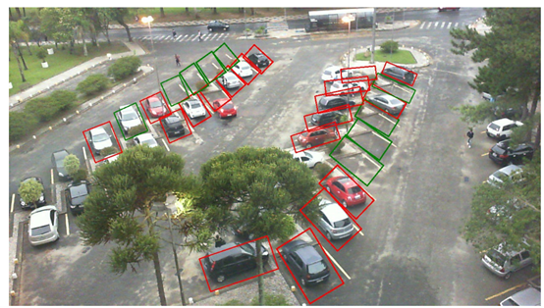

This application is through find white line of car space to detect position of car space.

The application implemented an AI algorithm that takes in an annotated image and draws a green coloured bounding box around the parking space if it is available and a red coloured bounding box if it is occupied. This included training a deep convolutional neural network to detect if a parking space is occupied or not.it trained a VGG model using transfer learning. It means to create image of empty car space of each rect and then compare those images with each frame of video. That allow system to detect is the free of car space.[6]

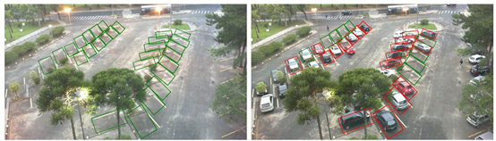

Advantages:

1. The trained model was able to achieve 99.5% accuracy on the validation set.

2. This application shows each rect of car space very clearly.

Disadvantages:

1. If barrier exists on the screen to hide line of car space, the system can not detect those position of car space.

2. Have to train VGG model by manual work, can only use for one car park.

3. It is difficult to detect white line when white line getting dim.

Snagging Parking Spaces with Mask R-CNN and Python[7]

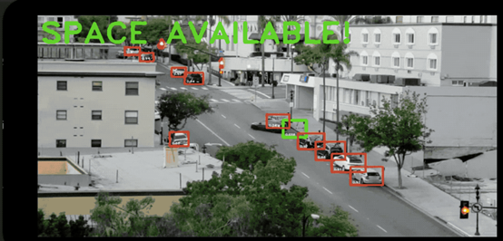

This application is use mask R_CNN to detect location and outline of car(ima1). This application through moving of car to check which position is car space, for example, if this car don’t move over 5 mins, then this position is car space, then draw a box in this position, if car move then change green box to red box finally send image and text by message to the user, tell user there have a car space available(ima2).[7]

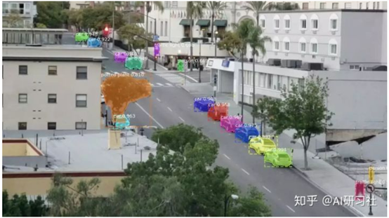

Ima1

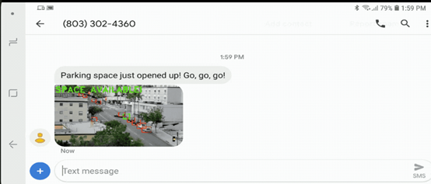

Ima2

Advantages:

1. It is easy to detect where is cars.

2. Don’t need manual work, system going to solve everything.

3. Shows red box and green box clearly.

Disadvantages:

1. It is difficult to detect cars when some barrier hide car.

2. If a car stays more than 5 mins on the other space, the system will Determine the position is car space.

Use opencv&tensorflow to detect car space[5]

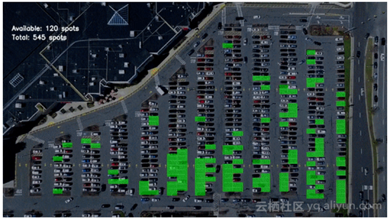

This application is use edge detection, hough transform to draw all of the car space(img3). Then allocate id for each car space. This application create a cnn model to create image of empty car space and car space which have car exists, That allow system to detect is the free of car space. (img4)[5]

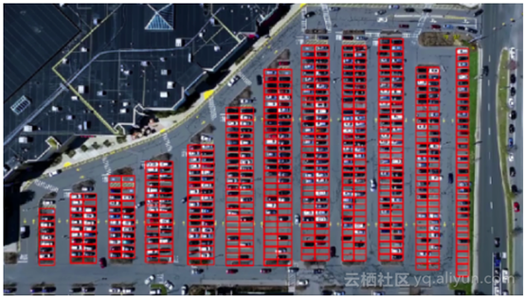

Img3

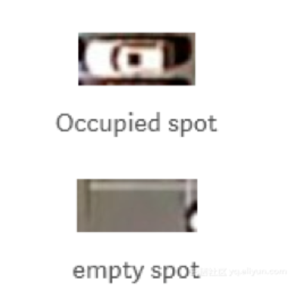

Img4

Advantages:

1. High accurate

2. Able to recognition small cars.

3. Shows number of car space available and total car space

Disadvantages:

1. The system may recognition space is not belonging car space.

2. Still have mistaken exists.

## 2.3. Technologies you’ve researched

Thonny is a beginner-friendly Python IDE, developed in University of Tartu, Estonia, which takes a different approach as its debugger is designed specifically for learning and teaching programming.[22]

Pycharm is an IDE(Integrated Development Environment) by Jetbrains. It is used for development in Python and frameworks like DJango. You can customize it with themes and plugins. It lets you to enhance productivity while coding by providing some features like suggestions, Local VCS etc.[17]

PostgreSQL is an object-relational database management system (ORDBMS). It is an open source system that is known for its close alignment with the SQL standard.[10]

Python programming language can be used to create image processing and recognition features.

OpenCV (Open Source Computer Vision) is a library of programming functions mainly aimed at real-time computer vision. In simple language it is library used for Image Processing. It is mainly used to do all the operation related to Images.[13]

Django is a high-level Python Web framework encouraging rapid development and pragmatic, clean design.[16]

## 2.4. Other Research you’ve done

convolutional neural network

A Convolutional Neural Network (ConvNet/CNN) is a Deep Learning algorithm which can take in an input image, assign importance (learnable weights and biases) to various aspects/objects in the image and be able to differentiate one from the other. The pre-processing required in a ConvNet is much lower as compared to other classification algorithms. While in primitive methods filters are hand-engineered, with enough training, ConvNets have the ability to learn these filters/characteristics.[23]

Mask R-CNN

We present a conceptually simple, flexible, and general framework for object instance segmentation. Our approach efficiently detects objects in an image while simultaneously generating a high-quality segmentation mask for each instance. The method, called Mask R-CNN, extends Faster R-CNN by adding a branch for predicting an object mask in parallel with the existing branch for bounding box recognition. Mask R-CNN is simple to train and adds only a small overhead to Faster R-CNN, running at 5 fps. Moreover, Mask R-CNN is easy to generalize to other tasks, e.g., allowing us to estimate human poses in the same framework. We show top results in all three tracks of the COCO suite of challenges, including instance segmentation, bounding-box object detection, and person keypoint detection. Without bells and whistles, Mask R-CNN outperforms all existing, single-model entries on every task, including the COCO 2016 challenge winners. We hope our simple and effective approach will serve as a solid baseline and help ease future research in instance-level recognition. Code has been made available at: this https URL[8]

Intersection Over Union

metric used to measure the accuracy of an object detector on a particular dataset. We often see this evaluation metric used in object detection challenges such as the popular PASCAL VOC challenge.[9]

## 2.5. Existing Final Year Projects

Project 1

Title: Euro Coin Classification Using Image Processing & Machine Learning

Student: Yumin Chen

Description (brief):

this project is through suitable mathematical model to recognition denomination of euro coin.

The main technologies involved in this project are image processing and machine learning. For Image Processing, computer vision techniques are used to process the image-based sample dataset and extract features. Machine Learning is used for predictive data analytics to build the models of generalized euro coin denominations.

This project allows human easy to calculate a large number of money.

What is complex in this project

Visual object recognition is one of the most challenging computational problems in machine vision. Humans can easily recognition any euro coin but machine can not, so have to create an artificial recognition system.

What technical architecture was used

JSON language, image processing techniques, machine learning techniques, data mining techniques, computer vision techniques, statistical techniques

Explain key strengths and weaknesses of this project, as you see it.

The strength of this project is allowed user easy to calculate money

The weakness of this project is this application have to scan each coin sometime is not necessary.

Project 2

Title: Image Selection Based on Optimal Characteristic Analysis

Student: Jameel Briones

Description (brief):

This project is through compare Basic image properties such as sharpness, noise level, exposure and contrast will be analyzed to test for the image’s quality to find similar image then category. User can share the image to social media site.

It helps user to tidy up images.

What is complex in this project

This project have to research and implement a good image comparison algorithm can to use to compare image’s quality.

Have to assessment measure for different image properties that can affect image quality

What technical architecture was used

Python language, opencv, image processing technical

Explain key strengths and weaknesses of this project, as you see it.

The strength of this project lies on the image quality assessment. The tests performed has produced a higher success rate than the image comparison, often matching human’s assessment of image quality. The image assessment is also made more efficient due to multithreading. It also provides a share functionality in the application.

project’s weaknesses lies on the image comparison. It may be accurate in a few samples, but it can also have a few outliers resulting from its brute force matching of its descriptors. Because of this, it often leads to an inaccurate matches of the images. It can also be quite slow at times, depending on the image size and quantity to be compared.

## 2.6. Conclusions

With the necessary gained knowledge of space checker and its associated problems, development stages of the app can begin with this knowledge in mind.

From research of similar applications, technologies and similar project, we have a good understanding about how to design the application.

The technologies best suited for the project were decided after researching many different options.

Requirements Table

|  |  |  |
| --- | --- | --- |
| **Name** | **Description** | **Priority** |
| User Login | Enables a user to login on website | HIGH |
| User Logout | Enables a user to logout of the website | HIGH |
| User create account | Enables user to create an account and enter relevant information about themselves | HIGH |
| User register | Allow user to register an account on the website | HIGH |
| Home page | Provide selecting of car park and shows the number of free space and status of space. | HIGH |
| database | create a database for application using postgresql | HIGH |
| deploy website | using django to deploy website shows login page and register page. | HIGH |
| space map | shows space id, status and position on space map and reference substance for car park. | HIGH |
| Select park | user can select different car park | MEDIUM |
| show total space | show total number of car space on home page | LOW |
| show car exist | show total number of cars exist on home page | LOW |

# 3. Prototype Design

**As least 6 pages, but as many as you like (but lots of diagrams, which count towards the page total).**

## 3.1 Introduction

Following on from the previous chapter, where some of the key background research was presented. The first section will look at the software methodologies employed in this project which describes which methodology was chosen and why. After that, some example use-cases and user personas will be presented. The next section outlines the technical architecture of the system and will discuss in depth how the system architecture is planned to work. This will cover both front-end and back-end aspects of the system. The final section will discuss the plan for testing and evaluation of the system.

## 3.2. Software Methodology

we choose waterfall Methodology for our project

Waterfall relies on teams following a sequence of steps and never moving forward until the previous phase has been completed. The methodology, in its traditional form, leaves almost no room for unexpected changes or revisions.[11]

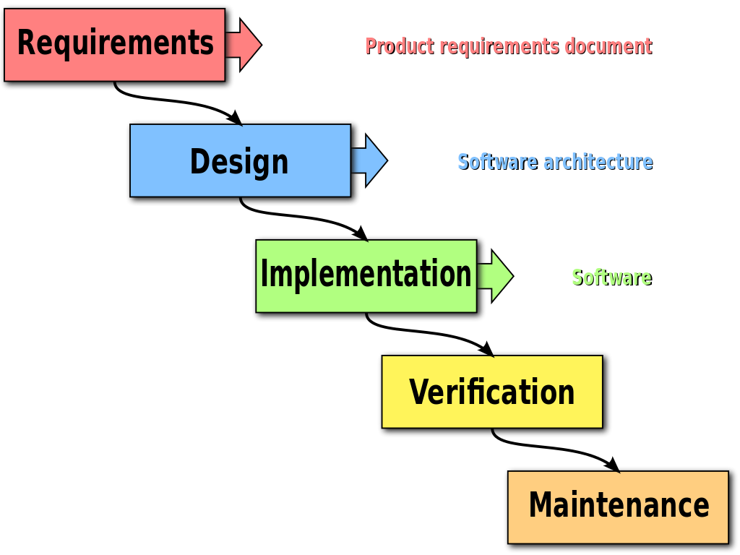

Advantages of the Waterfall model

Waterfall relies on teams following a sequence of steps and never moving forward until the previous phase has been completed. This structure is suited to smaller projects with deliverables that are easy to define from the start.

1. Uses clear structure

2. Determines the end goal early

3. Transfers information well

The disadvantages of the Waterfall model

Waterfall is a respected methodology, but lately it’s faced criticism for being an outdated model. The methodology’s limitations become more apparent depending on the size, type, and goals of the project it’s guiding. Rather than adapting your organization to Waterfall’s guidelines later, consider these limitations to assess whether Waterfall is truly a fit for your team.

1. Makes changes difficult

2. Excludes the client and/or end user

3. Delays testing until after completion

[11]

## 3.3. Overview of System

Model-View-Controller pattern approach will be used where a feature will be planned.

MVC Stands for Model View Controller and it's software architecture design pattern. The main goal of this architecture is to separate functionality, logic, and the interface of an application to promote organized programming.

The Model is responsible for getting and manipulating the data, so it's basically the brain of the application.

view is the user interface, it's what the user sees and how they interact with the application.

controller acts as kind of a middleman between the model and the view. The controller will ask the model to get some data from a database and then the controller will take that data and load a view and pass that data into it.[12]

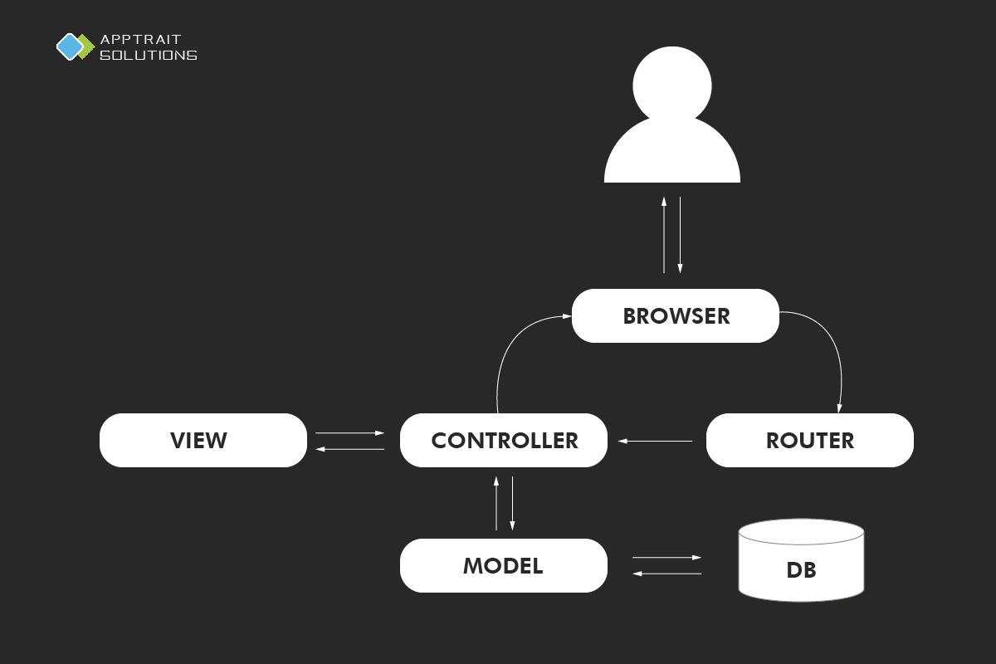

In django We use Model-Template-View(MTV) pattern is similar with MVC pattern, in Django views are called templates and controllers are called views. Hence our HTML code will be intemplates and Python code will be in views and models.Template is the view from MVC, View is controller from MVC.

The technical architecture shows how many layers there are in the application and how the layers communicate with each other. For this project a 3-Tier model will be used as seen below. This model was chosen as changes to one layer of the model should not affect the other layers.

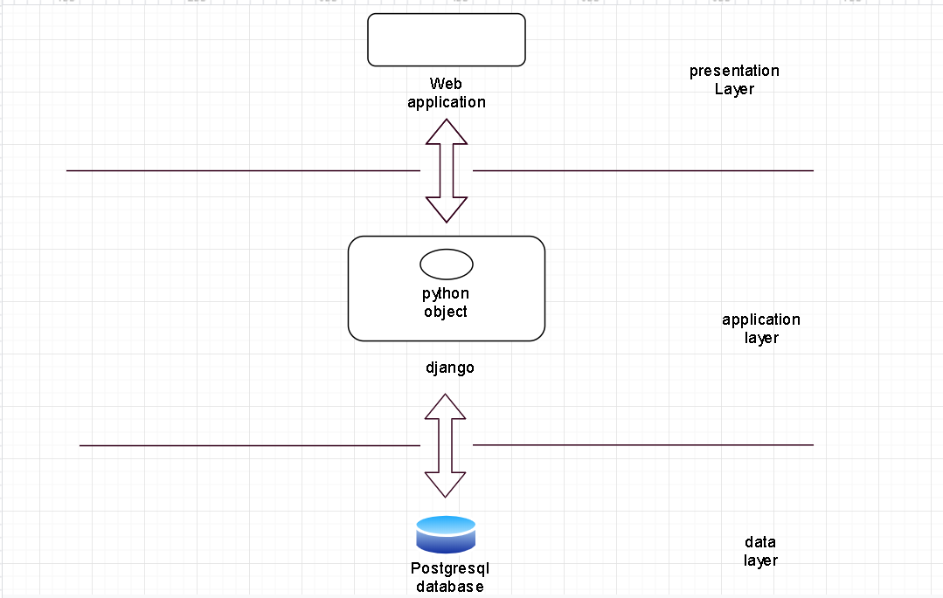

## 3.4. Front-End

Front end development is mostly focused on what some may coin the "client side" of development. Front end developers will be engaged in analyzing code, design, and debugging applications along with ensuring a seamless user experience. You manage what people first see in their browser. As a front end developer you are responsible for the look, feel and ultimately design of the site.[14]

we create prototype by Wix(a web design application), it shows good front-end. we will clearly understand what the end product looks like.

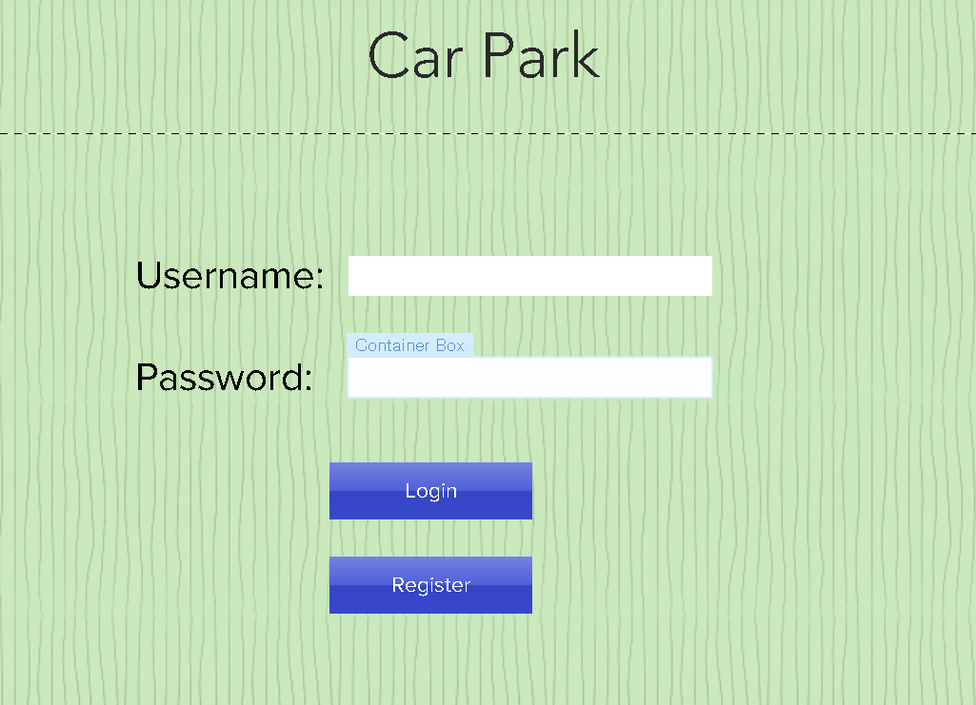

this is the login page, users have to login first, then return to homepage, if user do not have an account, then have to click the register button go to register page.

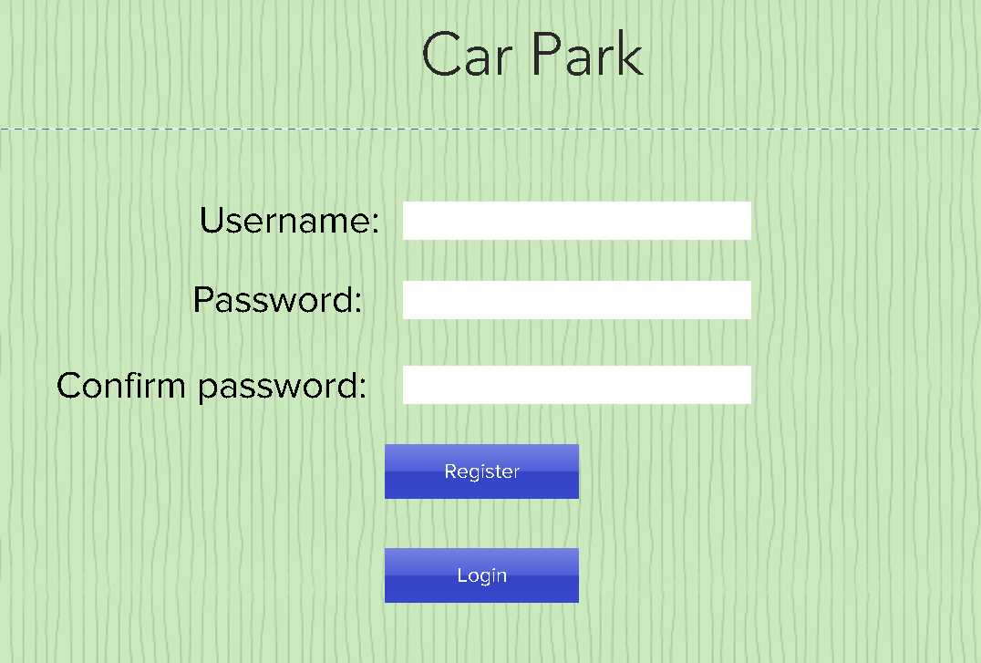

this is register page, this page allowed user to create a account.

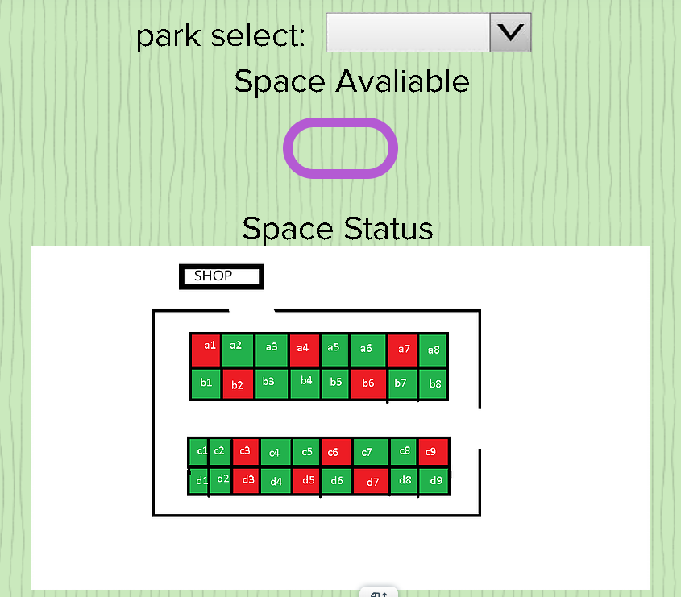

this is homepage, it allow user to select car park and then shows the number of free space and status of space.

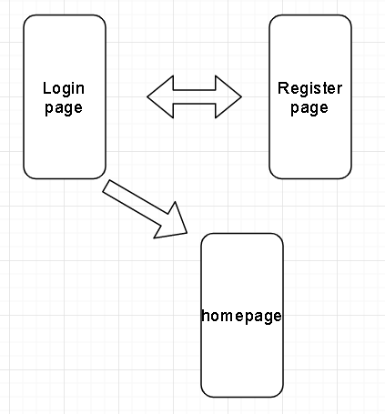

This is medium fidelity prototype.

## **Use Case Diagrams**

Use case diagrams are used to identify system functionality and communicate system behaviour. The use case diagrams in the below figures show the progression of the system functionality.

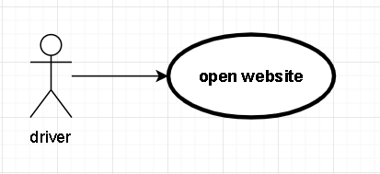

1st Iteration Use Case Diagram.

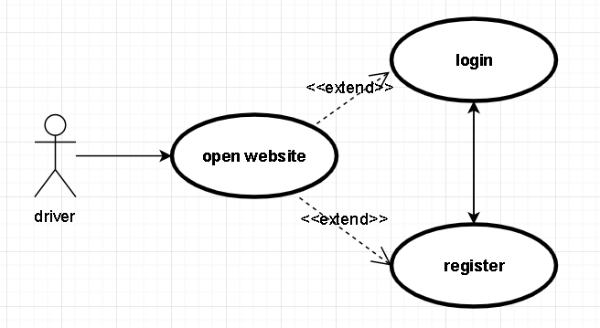

2nd Iteration Use Case Diagram.

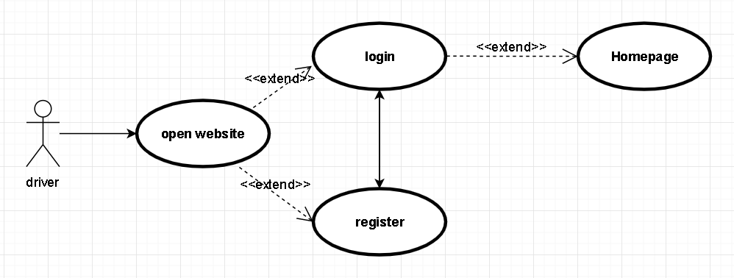

3rd Iteration Use Case Diagram.

## 3.5. Middle-Tier

In most three-tier web database systems, the majority of the application logic is in the middle tier. The client tier presents data to and collects data from the user; the database tier stores and retrieves the data. The middle tier serves most of the remaining roles that bring together the other tiers: it drives the structure and content of the data displayed to the user, and it processes input from the user as it is formed into queries on the database to read or write data. It also adds state management to the HTTP protocol. The middle-tier application logic integrates the Web with the database management system[15].

our middle tier is django, Django is a high-level Python Web framework that encourages rapid development and clean, pragmatic design. [16]

The goal of django is to allow developers to instead of implementing the same solutions over and over again, focus on the parts of their application that are new and unique to their project. In fact, Django is much more fully featured than many other frameworks out there. It takes care of a lot of the hassle of Web development, letting you focus on writing your application without any need to reinvent the wheel. It’s free and open source. Additionally, the Django framework enables you to model your domain and code classes, and before you know it, you already have an ORM. Let’s take a closer look to understand its acclaim better.[16]

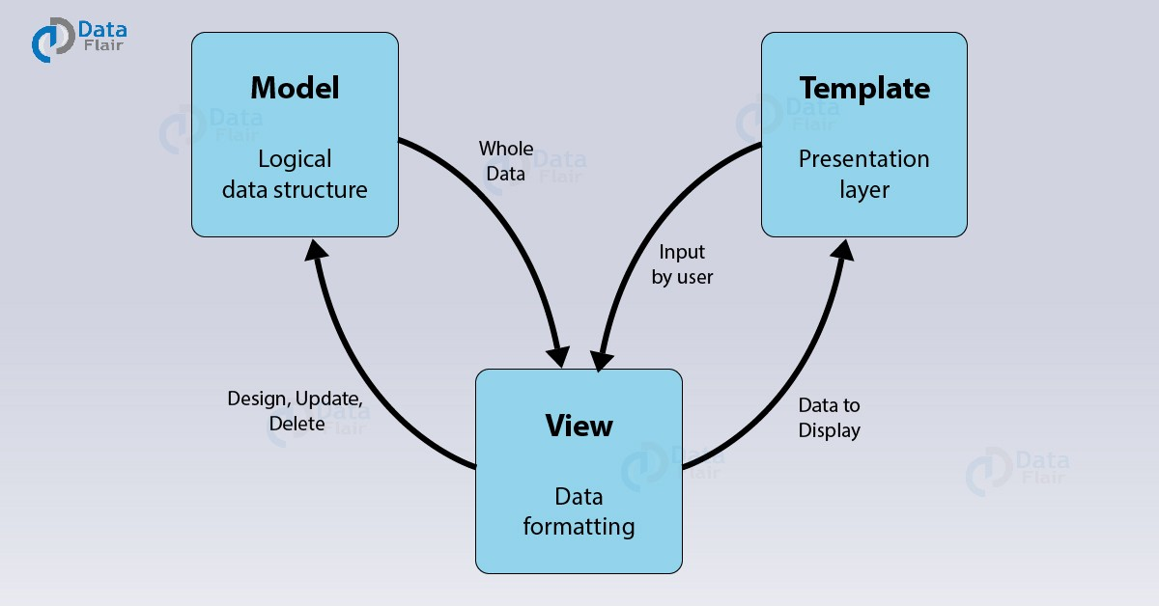

## 3.6. Back-End

The Data Layer comprises of the data storage system and data access layer. This is the DBMS layer and is generally accessed through the middle layer applications.

we use postgresql as our data layer.

PostgreSQL is an object-relational database management system (ORDBMS). It is an open source system that is known for its close alignment with the SQL standard.[10]

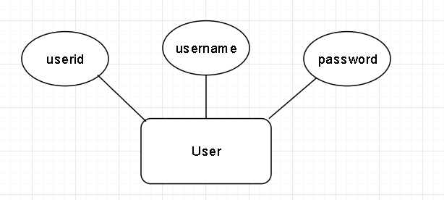

1st Iteration ERD

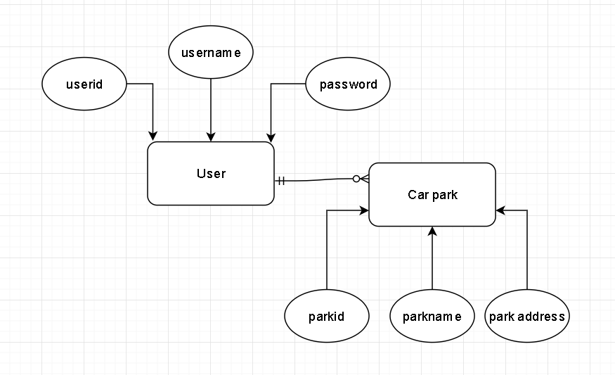

2nd Iteration ERD

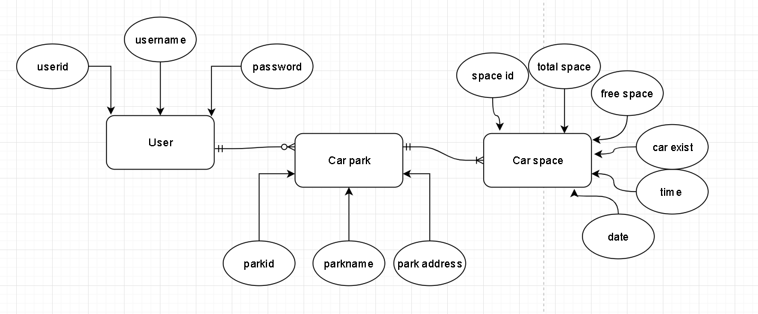

3rd Iteration ERD

## 3.7. Conclusions

In this chapter we looked at the design of the system, first exploring the methodology that will be used in the development process, next a broad overview of the technical architecture was outlined, then into detail the front and back-end design. Finally testing was discussed regarding the different testing methods that will be followed and the software test plan.

Based on the key themes discussed in this chapter, the next chapter will cover the development process and will be revisiting many of the same issues covered here. The development chapter will discuss how these designs were implemented including any challenges or changes encountered along the way.

# 4. Prototype Development

**As least 2 pages, but as many as you like (but lots of code samples).**

## 184.1. Introduction

This chapter continues with the issues explored in the previous chapter and will outline the development process undertaken in this project. This chapter will present the key development processes and the challenges encountered during the creation of this system.

## 4.2. Prototype Development

The first step for the development of the application was to set up version control.

we decided to use GitHub to implement version control, because github can easily integrated django of Pycharm and we can use each change of commit as a version. Git is the most commonly used version control system today and is quickly becoming the standard for version control. Git is a distributed version control system, meaning your local copy of code is a complete version control repository.[18]

for prototype development, we decide to use django create 3 website: login page, register page and home page, then create database for login and register after using postgresql.

## 4.3. Front-End

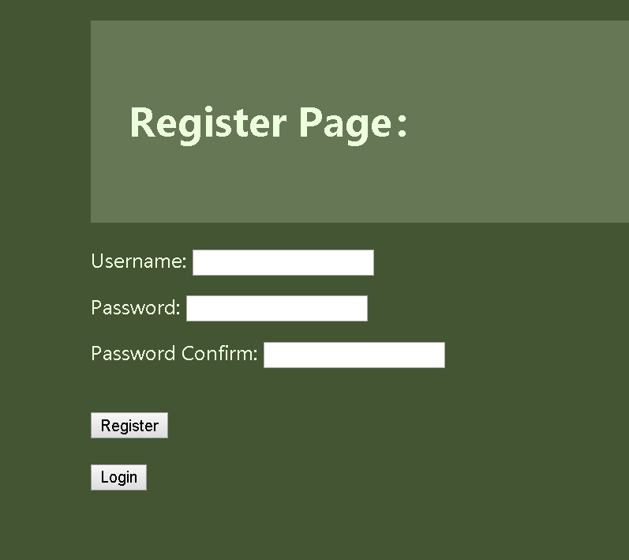

register page have 2 buttons: register and login. click register button able to tell user register is successful or false. click the login button will go to the login page.

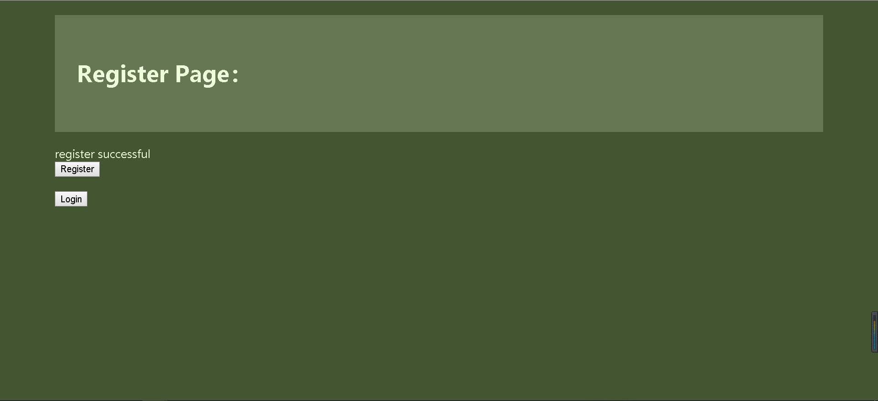

if register successful then will tell user.

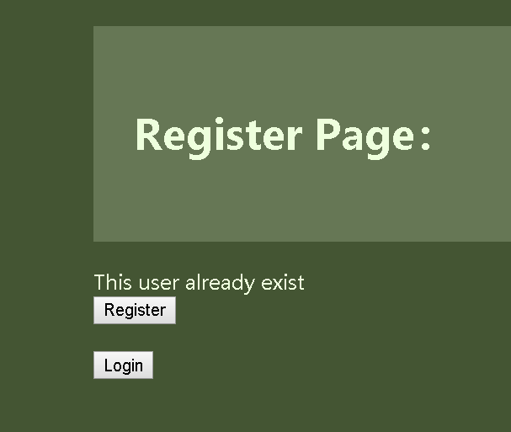

enter same username again.

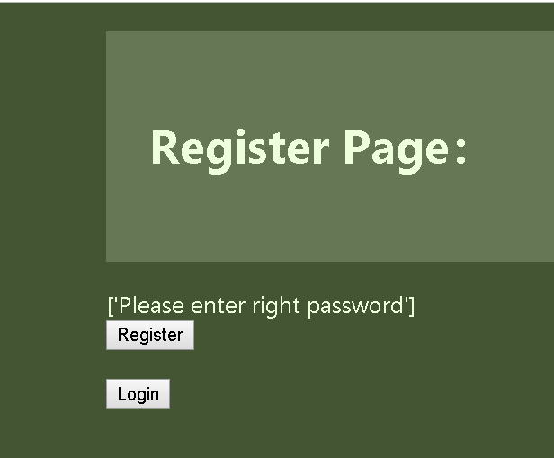

enter different password between password and password confirm.

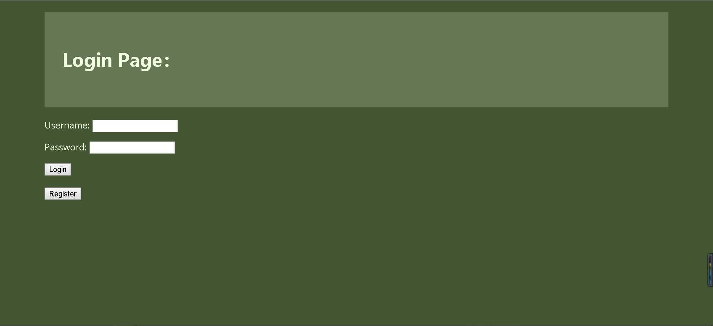

login page

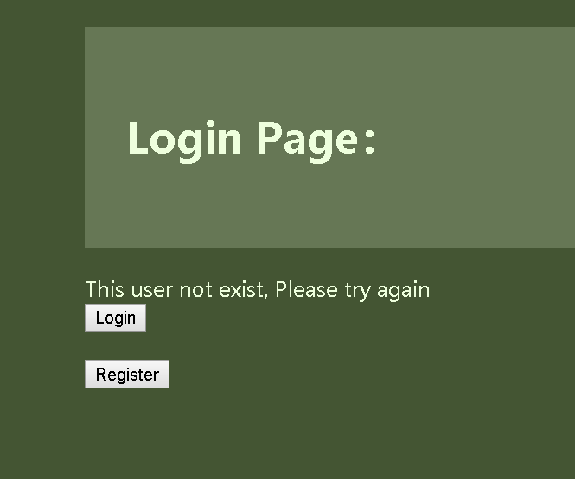

if username or password wrong.

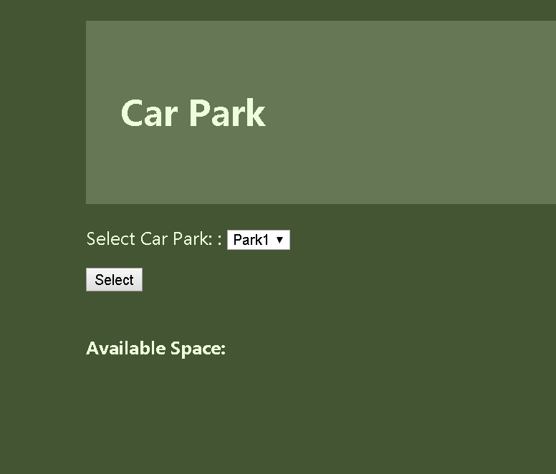

if login success will go to homepage.

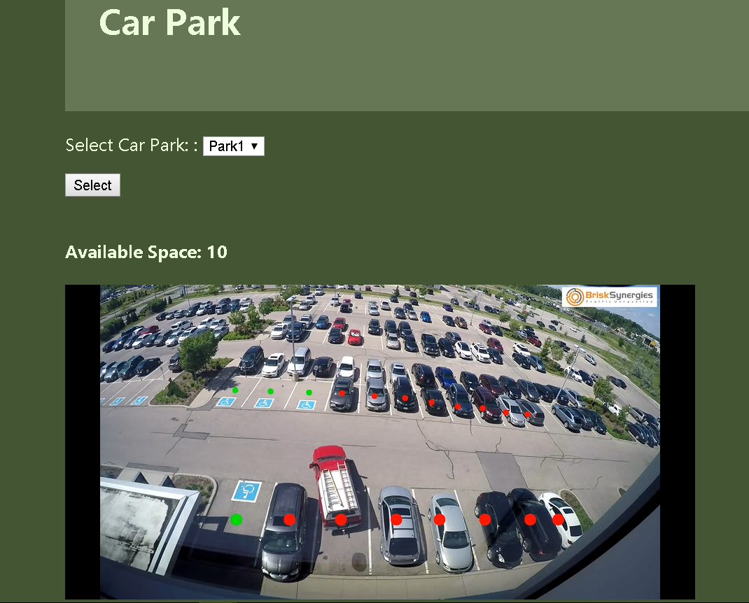

Click the select button to select park 1 will show a space no and video to tell user status of space.

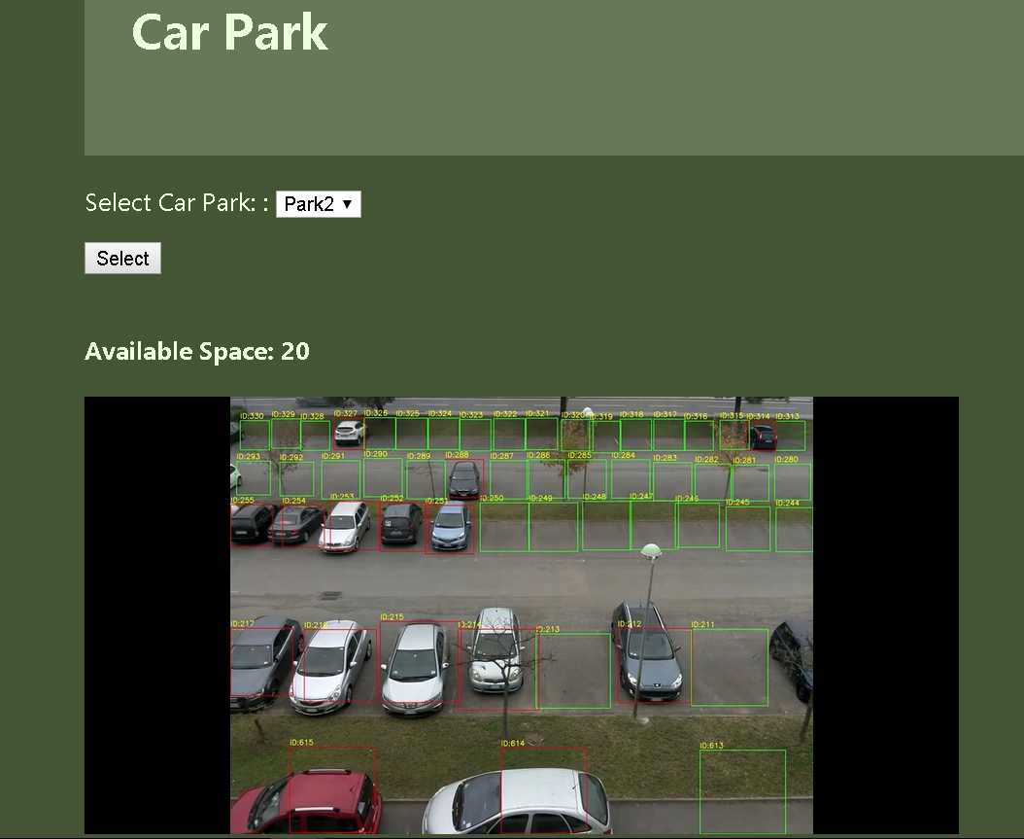

Click the select button to select park 2 will show a different car park to tell user status of space.

## 4.4. Middle-Tier

we use pycharm to design code.

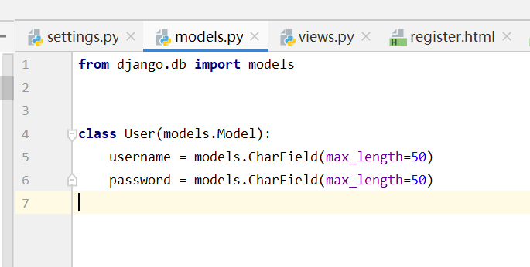

use to create user table in postgresql.

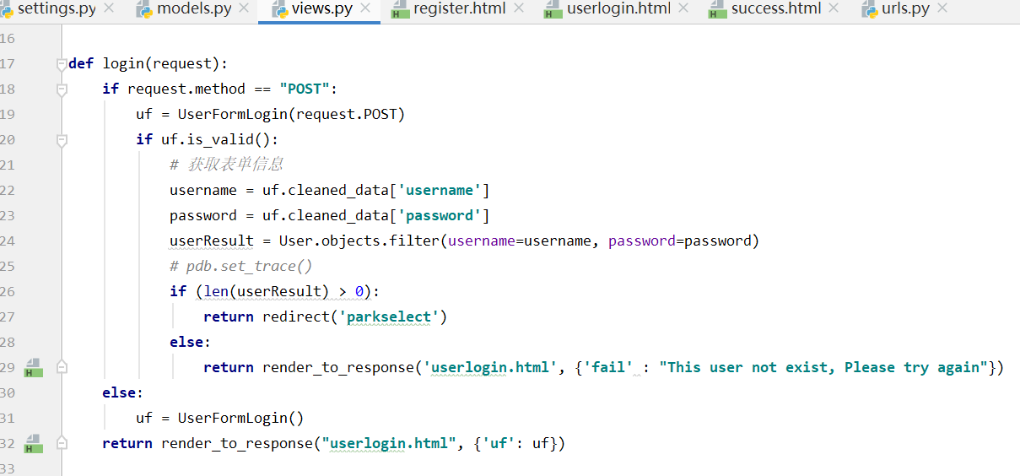

use to implement login, check username and password exists in database, if not exist return false, if exist go to home page.

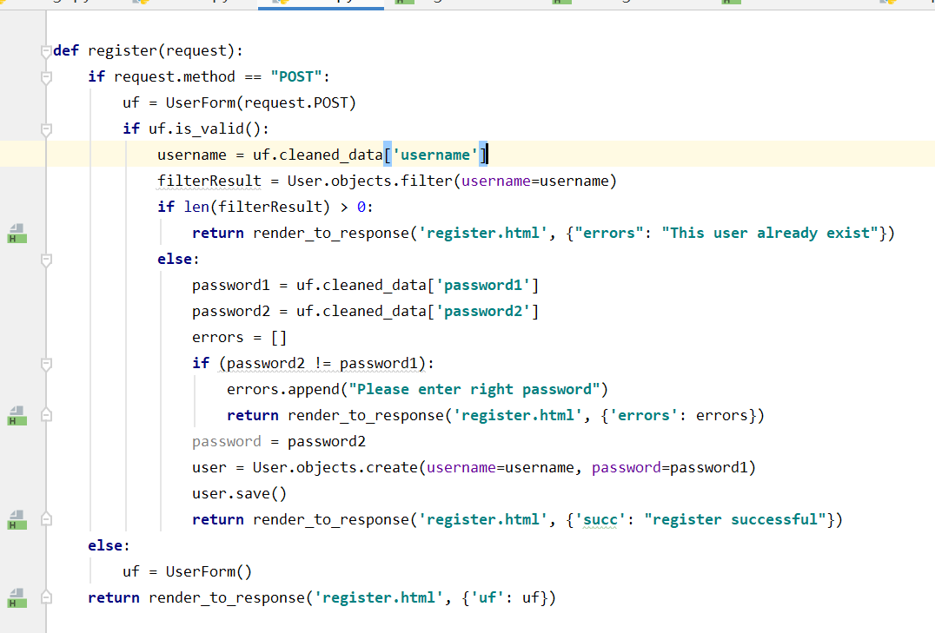

use to implement register, update username and password into database, if password is different return false, if username already exist in database return false.

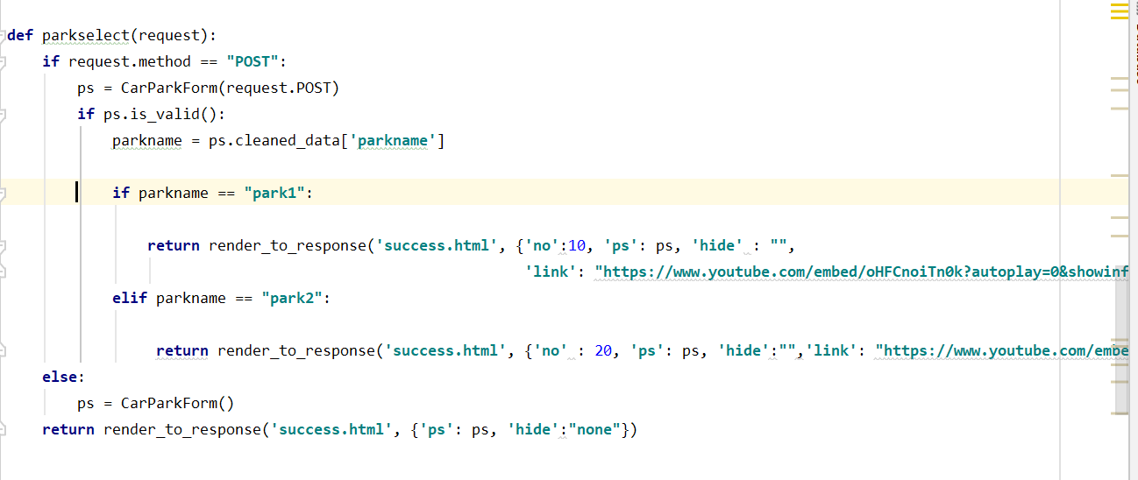

use to implement park select, if value of drop down list is park 1 will show number of space and video of park 1, if value of drop down list is park 2 will show number of space and video of park 2

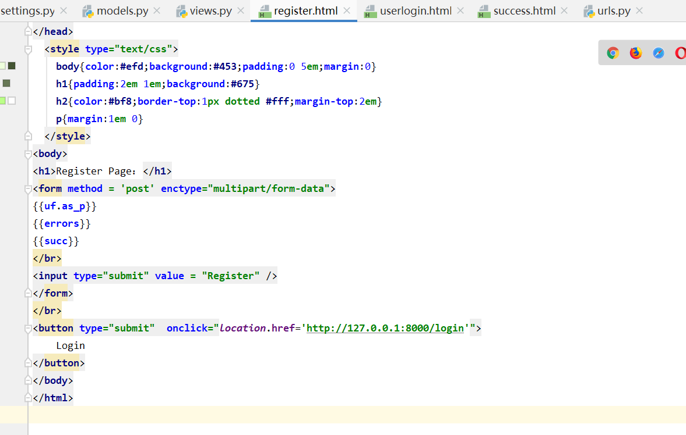

this is html file of the register page.

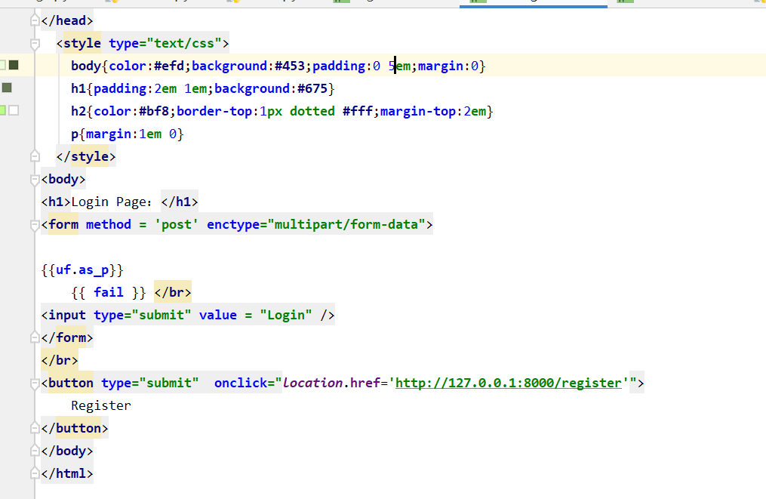

this is html file of login page.

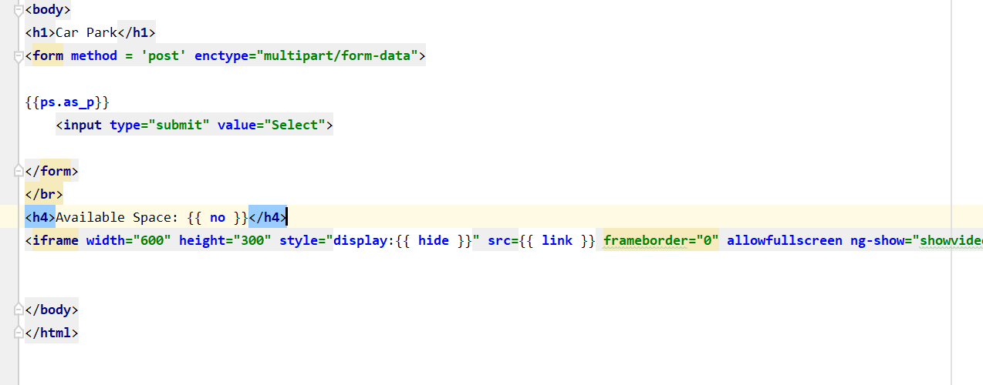

this is html file of home page.

## 4.5. Back-End

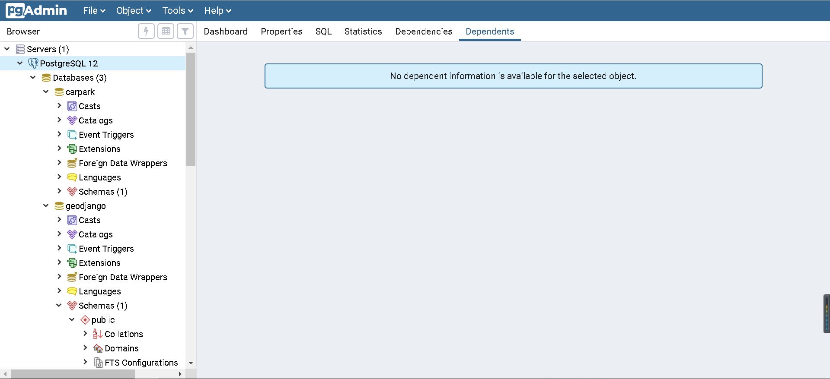

this is admin of postgresql.



table of user.

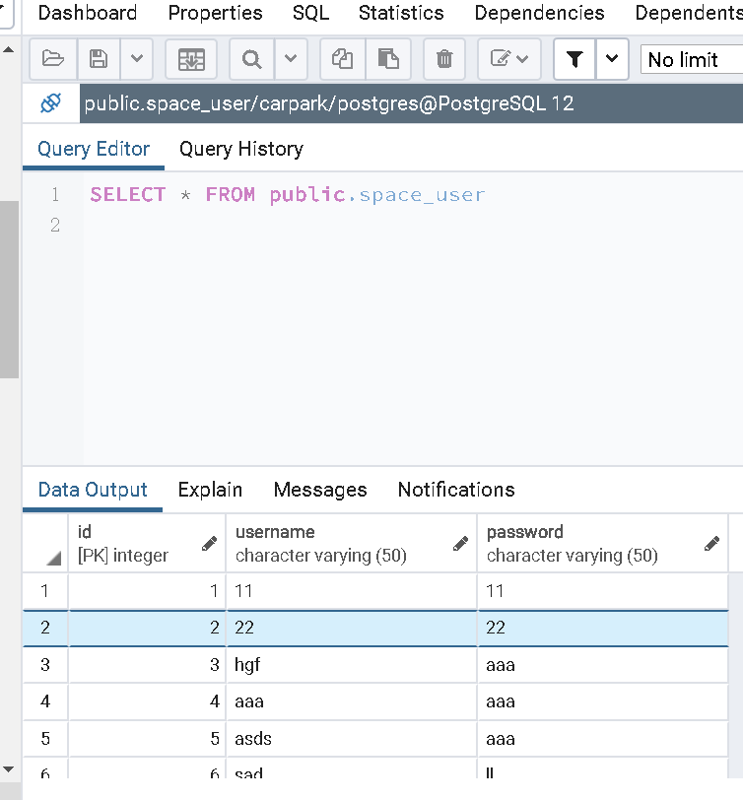

values from user table.

## 

## 4.6. Conclusions

In this chapter we start design a simple system, first explain methodology that was used in the development process, next a broad overview of the technical architecture was outlined, then into detail the front and back-end design in prototype development.

The next chapter will talk about testing of project.

# 5. Testing and Evaluation

**As least 2 pages, but as many as you like**

## 5.1. Introduction

This chapter describes how all the testing and evaluation of the system was executed. Each phase of testing will be described in detail.

## 5.2. Plan for Testing

Testing is how you spot the errors. A structured approach to testing, as managed through a test phase, is the way to do it. Methodically working through the various processes and deliverables gives you a solid base for being able to say you are delivering what you said you would. Testing can be a good sense check to make sure our deliverables are fit for purpose[19].

Backing up and committing the project consistently using GIT version control will ensure that any changes can be rolled back if there are any major errors. Having multiple project backups will help in the inevitable “accidently deleting an important part of the project”.

We may ask other people to evaluate our web application, then we knows how to develop our project.

first we would mix white box test and unit test would be an adequate way to test project. It make sure no errors in each unit of application. after we use black box and Integration Testing to test project, it make sure bo error between each unit and model.

Black Box Testing is a software testing method in which testers evaluate the functionality of the software under test without looking at the internal code structure. This can be applied to every level of software testing such as Unit, Integration, System and Acceptance Testing.[20]

White Box Testing is based on applications internal code structure. In white-box testing an internal perspective of the system, as well as programming skills, are used to design test cases. This testing usually done at the unit level.[20]

A unit test is a test written by the programmer to verify that a relatively small piece of code is doing what it is intended to do. They are narrow in scope, they should be easy to write and execute, and their effectiveness depends on what the programmer considers to be useful. The tests are intended for the use of the programmer, they are not directly useful to anybody else, though, if they do their job, testers and users downstream should benefit from seeing fewer bugs.[21]

An integration test is done to demonstrate that different pieces of the system work together. Integration tests can cover whole applications, and they require much more effort to put together. They usually require resources like database instances and hardware to be allocated for them. The integration tests do a more convincing job of demonstrating the system works (especially to non-programmers) than a set of unit tests can, at least to the extent the integration test environment resembles production.[21]

|  |  |  |  |
| --- | --- | --- | --- |
| **Test No** | **Test Description** | **Expected Outcome** | **Pass?** |
| 1 | click the register button on register page | return text tell user register successful or false. |  |
| 2 | enter different values in password and password confirm on register page | return text tell user password is wrong |  |
| 3 | when login and register leave some fields empty | show text tell user to enter data. |  |
| 4 | click the login button in on register page | return to login page |  |
| 5 | enter same username somebody enter before on register page. | return text tell user username already exist. |  |
| 6 | click the register button on the login page | return to register page |  |
| 7 | click the login button on the login page | if false will return text tell user username or password wrong, if success will return to homepage |  |
| 8 | select park and click the select button on homepage | can shows right number of free space and video for each car park. |  |

## 5.3. Plan for Evaluation

Evaluation of this system is equally as important as testing. The reason for this is that user experience is one of the main complexities of the application.

we use 10 Usability Heuristics for User Interface Design to evaluate space checker.

Jakob Nielsen's heuristics are probably the most-used usability heuristics for user interface design. They are called “heuristics” because they are broad rules of thumb and not specific usability guidelines.[24]

01. Visibility of system status

02. Match between system and the real world

03. User control and freedom

04. Consistency and standards

05. Error prevention

06. Recognition rather than recall

07. Flexibility and efficiency of use

08. Aesthetic and minimalist design

09. Help users recognise, diagnose, and recover from errors

10. Help and documentation

## 5.4. Conclusions

This chapter reviewed the testing and evaluation of the system. The testing consisted of performing Unit Testing and Integration Testing both while developing the system and on completion. The evaluation included Nielsen’s heuristics.

# 6. Issues and Future Work

**As least 5 pages, but as many as you like**

## 6.1. Introduction

This chapter will reflect on the entirety of the project and will discuss the conclusions drawn, personal reflections made, and the future work planned for the project.

## 6.2. Issues and Risks

The challenges that are unresolved in the project thus far are as follows:

* Lack of familiarity with opencv about image processing
* Lack of knowledge with Machine learning, Classification, Deep learning and Convolutional neural networks
* Lack of familiarity with using opencv in django.
* do not know upload video which is processed by opencv to website.

How the author plans on approaching these various challenges are as follows(respectively):

* read books and research on the internet about how to use opencv and jango
* looking for similar application to research how to achieve the application.

The risks that the author faces in the project are as follows:

* our method can not shows all car space from video.
* video too short can not exactly our project does.

same method can be used for a video but can not use for another video.

How the author plans on approaching these various risks are as follows:

* try to find a best method can suitable use for our application.
* try to find suitable videos for our project and use our application to test it.

## 6.3. Plans and Future Work

The plan for the project can be seen in the GANTT chart below. Another GANTT chart will be filled in as the project is completed and these two charts will be able to be compared at the end to see the difference between the planned approach and the reality.

The project will continue to develop about using different videos of car park, we hope users can easily understand where free space is.

### 6.3.1. GANTT Chart

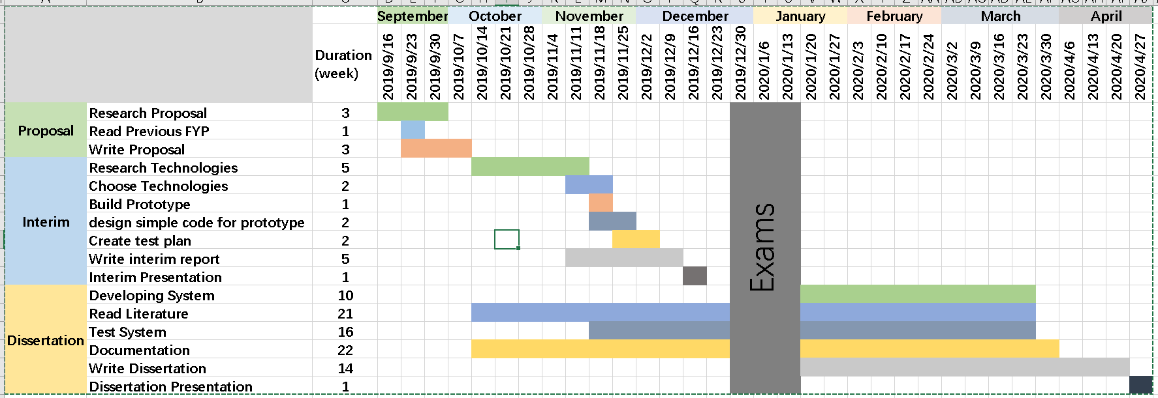

# Bibliography

5. fangxiang, “base Opencv&Tensorflow implement looking for car space”, 2018-10-26, <https://segmentfault.com/a/1190000016849300>

6. Sabina Pokhrel, “Smart Parking — An Application Of AI”, 2019-10-10,

<https://towardsdatascience.com/smart-parking-an-application-of-ai-9a4af90b1de6>

7. Adam Geitgey, “Snagging Parking Spaces with Mask R-CNN and Python, Adam Geitgey”, 2019/01/21,

<https://medium.com/@ageitgey/snagging-parking-spaces-with-mask-r-cnn-and-python-955f2231c400>

8. Kaiming He, Georgia Gkioxari, Piotr Dollár, Ross Girshick, “Mask R-CNN”, 20 Mar 2017 <https://arxiv.org/abs/1703.06870>

9.Adrian Rosebrock, “Intersection over Union (IoU) for object detection”, November 7, 2016 <https://www.pyimagesearch.com/2016/11/07/intersection-over-union-iou-for-object-detection/>

10. IAN, “What is PostgreSQL?”, 19/6/2016, <https://database.guide/what-is-postgresql/>

11.Lucidchart Content Team, “The Pros and Cons of Waterfall Methodology”, November

02, 2017 <https://www.lucidchart.com/blog/pros-and-cons-of-waterfall-methodology>

12. Dipen Patel , “ An Introduction to MVC Architecture: A Web Developer's Point of View”, 17 Jun 2019, <https://dzone.com/articles/introduction-to-mvc-architecture-web-developer-poi>

13. Rahul Galgali, “What is openCV?”, 27/2/2016, <https://www.quora.com/What-is-openCV>

14. Lauren Stewart, “Front End vs Back End Development”, January 14, 2019, <https://www.coursereport.com/blog/front-end-development-vs-back-end-development-where-to-start>

15. David Lane, ” Web Database Applications with PHP, and MySQL”, Hugh E. Williams, March 2002, <https://www.oreilly.com/library/view/web-database-applications/0596000413/ch01s03.html>

16. Amit Ashwini, “What Is Django And Why Is It So Popular?” 23/11/2017, <https://medium.com/swlh/what-is-django-and-why-is-it-so-popular-2b225620cca0>

17. Anuj Gupta, “What is PyCharm used for?”, 12/4/2017, <https://www.quora.com/What-is-PyCharm-used-for>

18. Kayla Ngan, “What is Git”, 05/04/2018, <https://docs.microsoft.com/en-us/azure/devops/learn/git/what-is-git>

19. Erika Rykun, “3 Reasons Why You Should Plan Your Testing Phase”, 31 July 2018, <https://pmtips.net/article/3-reasons-why-you-should-plan-your-testing-phase>

20. Rajkumar, “Black Box And White Box Testing | Definition And Types” , 30/7/2019, <https://www.softwaretestingmaterial.com/black-box-and-white-box-testing/>

21. Nathan Hughes, “What's the difference between unit tests and integration tests?”, 12/12/2018, <https://stackoverflow.com/questions/5357601/whats-the-difference-between-unit-tests-and-integration-tests>

22. Aivar Annamaa, “Learn to code with Thonny — a Python IDE for beginners”, 19/02/2018,

<https://fedoramagazine.org/learn-code-thonny-python-ide-beginners/>

23. Sumit Saha, “A Comprehensive Guide to Convolutional Neural Networks — the ELI5 way”, 15/12/2018, <https://towardsdatascience.com/a-comprehensive-guide-to-convolutional-neural-networks-the-eli5-way-3bd2b1164a53>

24. 10 Usability heuristics explained, Eranga Liyanage,Oct 2, 2016, <https://medium.com/@erangatl/10-usability-heuristics-explained-caa5903faba2>

25.